U.S.H. - PRODUCTION OF RESCUE SYSTEMS LTD. VODŇANSKÁ 2051/11 PRAHA 9
Phone/Fax: 00420281918828 e-mail:info@ushrescue.com, e-mail:ushsro@seznam.cz www.ushrescue.com

Order rescue parachute system USH
Company :

Address:

Telefon:

E-mail:

Type the rescue parachute system: | USH 150, USH 35 C, USH 35 soft, USH 52 S U USH 520 C, USH 520 soft, USH 600
Size of soft cont.: [mm USH 520:  USH 52 S:  USH 600: | 145x260x400, 150x230x420 mm  145x260x450, 150x230x430 mm  145x260x480, 270x200x400 mm
Number of units:
Connecting line [SPL] : | 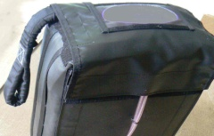  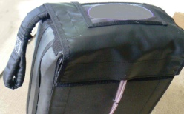  Left Right
Lenght of activation bowden [m]:

The number and length of anchor rope [m] :
The system will be used for aircraft type:
Ordered date:

Signature:

X

Type the rescue parachute systém, Size of soft Left Connecting line

